Lab Report 1

Lab Group Members: Marissa Kuo, Yen-Jung(Tim) Lu, Hugo Muro Avila

**Introduction**

This lab is built to let students learn how to work with the breadboard and connected sensors, output components, and integrated circuits with logic gates. Also, students learn how to design, test, and implement a logic circuit based on a functional specification.

Marissa:

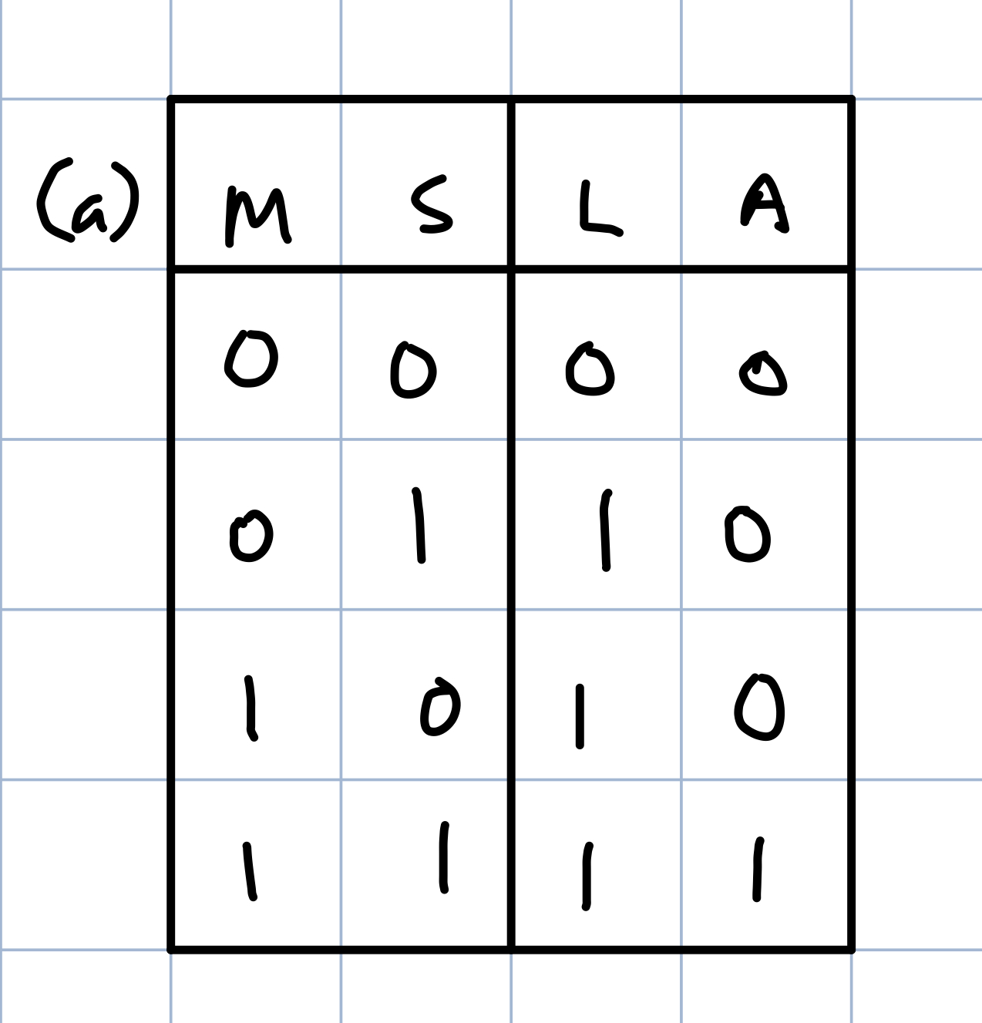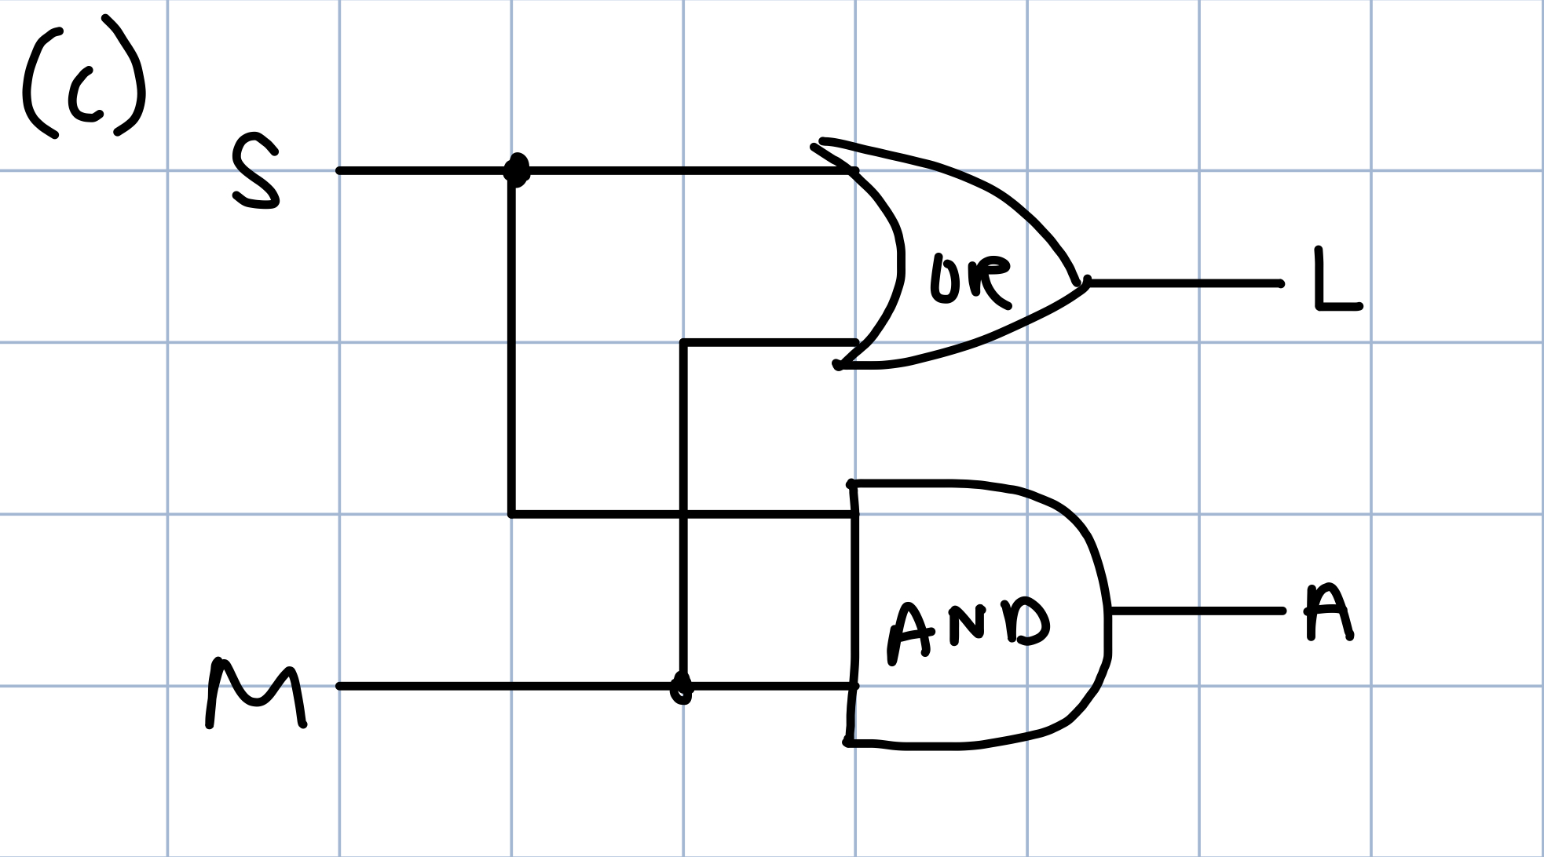

Tim:

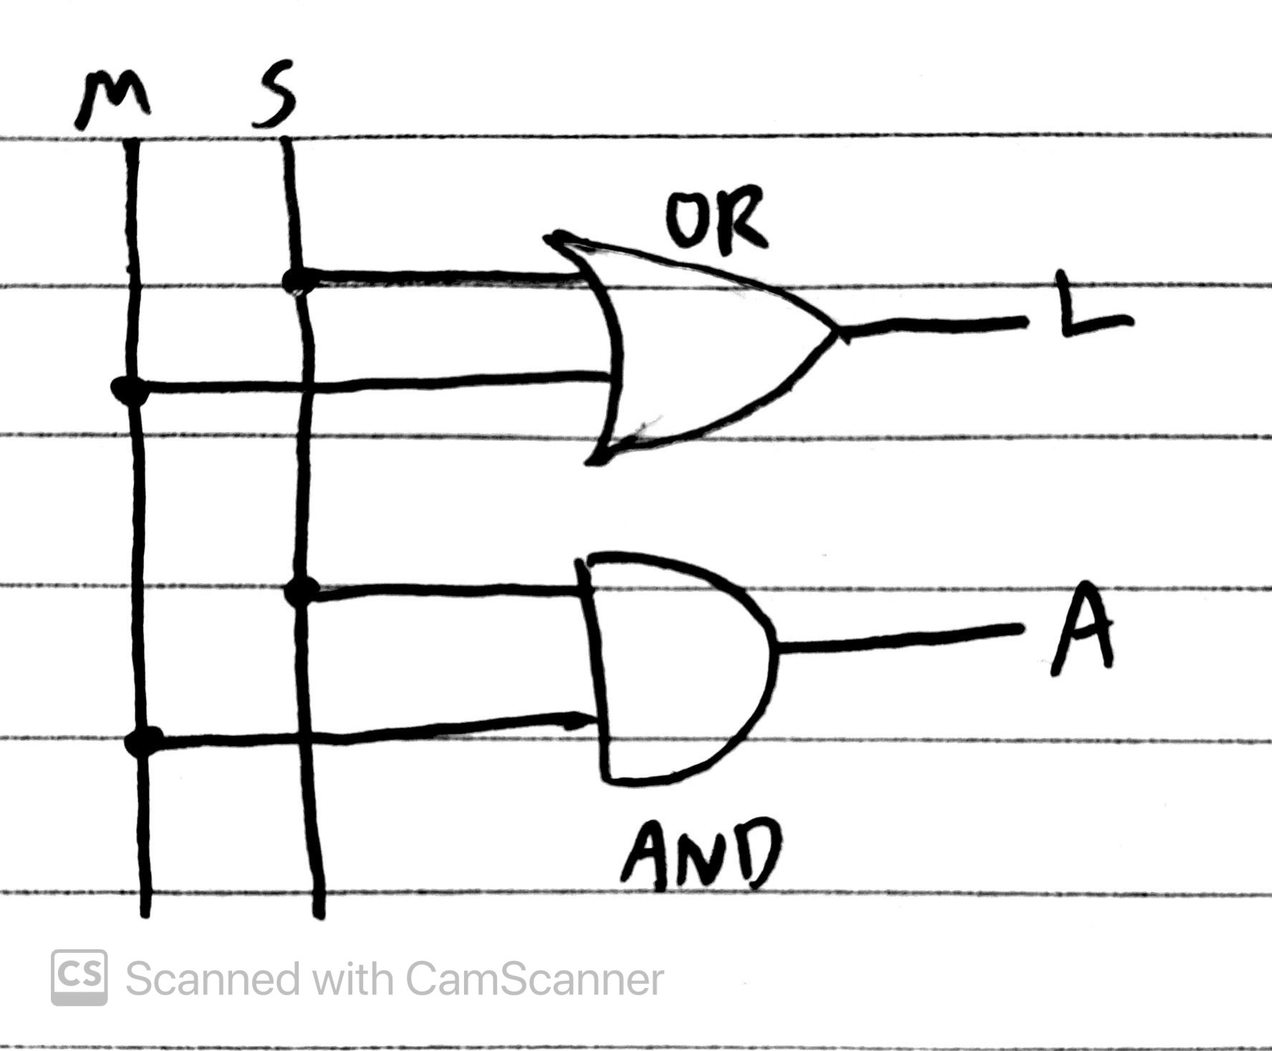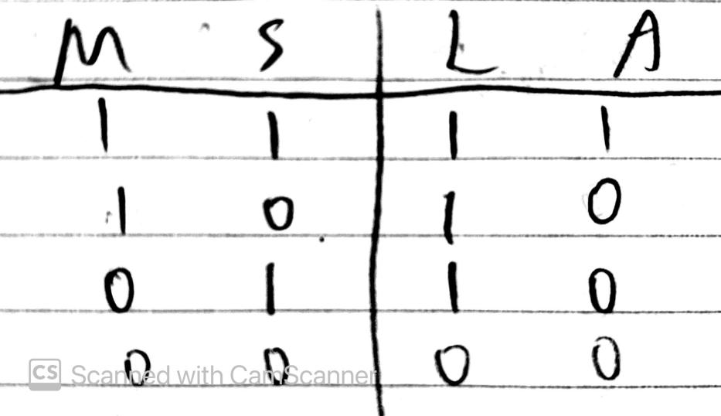

Hugo:



**Part I**

1. Observations:

The red LED turns on when connected to +5V; the green LED turns on when connected to ground.

This means that red must be internally connected to ground, while green must be internally connected to +5V because the LEDs are only turned on when there is a voltage difference.

3

1. Observations:

When the switch is down(0), the green LED turns on. When the switch is up(1), the red LED turns on.

1. Observations:

i. The LED alternates between red and green. The red LED turned on about 15 times in 30 seconds.

ii. The LED alternates much faster, with the red LED flashing 10 times faster than before on i.

iii. Since the power alternates much faster, both LEDs appear to be on at the same time. Visually, both of the LEDs appear to be on at the same time. However, in reality the signal is still alternating between both of them; it is just happening so quickly that the downtime between blinks is negligible, and to us it looks constantly on.

iv. At the maximum of 100K, the LEDs next to LED 4 also light up, and they dim the further away they are from LED 4. This is mostly likely due to the fact that these LEDs are in parallel, so when one of them gets a larger amount of voltage, other LEDs at the side will also light up. If the LED islocated further away from the LED4, the voltage would be weaker, hence the light would be dimmer.

**Part III**

**Lab and Testing Procedures:**

* We initially built the circuit as we had planned, using what we thought were the correct inputs and outputs, power connections, etc.
* When we first tried going through the truth table to make sure the circuit worked, we encountered two problems. First, our buzzer/alarm was not activating at all, no matter how many times we tried.
* Secondly, the motion detector proved to be very slow when changing output, and at times did not seem to work at all.
* After rewiring the whole circuit and confirming that everything seemed to be wired correctly, we received help from the lab assistant, who reviewed our circuit and discovered the main problems.
* First, the AND IC turned out to have a bad pin that we were trying to connect to, so we received a new IC and replaced it in the circuit.
* Finally, we discovered that we had connected the motion sensor to the incorrect power supply. Since the motion sensor needed a +4V power supply, we had to use the +V and -V connections. After testing and changing the voltage difference with a voltmeter, we connected the motion sensor to the new power connections, and tried again.
* After fixing these two errors, we went through the truth table again, and were able to confirm that the correct outputs were displayed.

**Original Results**

| S | M | L | A |
| --- | --- | --- | --- |
| 0 | 0 | 0 | 0 |
| 0 | 1 | 1 | 0 |
| 1 | 0 | 1 | 0 |
| 1 | 1 | 1 | 0 |

**Correct Truth Table**

| S | M | L | A |
| --- | --- | --- | --- |
| 0 | 0 | 0 | 0 |
| 0 | 1 | 1 | 0 |
| 1 | 0 | 1 | 0 |
| 1 | 1 | 1 | 1 |

In the end, the circuit was the same as the one we designed in the pre-lab:

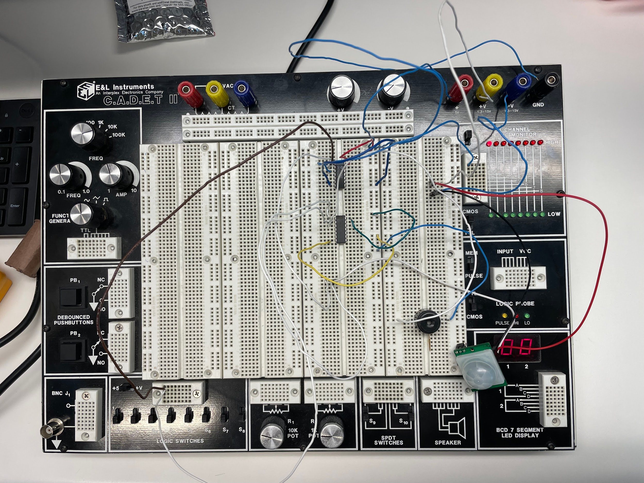

*Questions:*

1. Suppose the alarm system is functioning in such a way that the alarm (A) is activated as soon as motion is detected. List the possible issues with this system and how you could determine if the system is acting incorrectly.

Possible Issues:

* Alarm is wired to the OR IC.
* Alarm is directly tied to the input of the motion sensor.
* The light was turned on by the switch before the motion sensor detected the object.

Solution:

* Check to make sure If the alarm output is wired to the AND IC, rather than the OR IC. If so, we would need to remove it, and connect it to the AND IC output.
* Check to make sure that the input of the motion sensor is going to the AND IC, and that the output wire from the same IC is connected to the alarm.
* If the light was turned on by the switch before the motion sensor detected the object, then there is nothing we need to change, because this is part of the design.

1. Suppose the alarm system is operating in such a way that the alarm (A) goes on continuously regardless of the state of the other inputs. List the possible issues with this system and how you could fix this issue.

Possible Issue:

* Alarm was wired directly to the +5V source.

Solution:

* Rewire the circuit, to make sure the alarm is connected to the AND IC out instead of the +5V source.